🧶

**PoD Attendance Bot DEMO.**

Between 8 to 15 Feb, the PoD Attendance Bot is available for demo. This means PoD Shepherds may try out the service in action. Note that information collected during this period will be discarded after 15 Feb. Hence, feel free to try it out and share your feedback.

This is a service to simplify and centralise the attendance taking process within People of Destiny (PoD), so that Shepherds can understand member patterns and take proactive steps to encourage them. Hebrews 10:25 says *"Let us not give up meeting together, as some are in the habit of doing, but let us encourage one another—and all the more as you see the Day approaching".*

Here’s how it works.

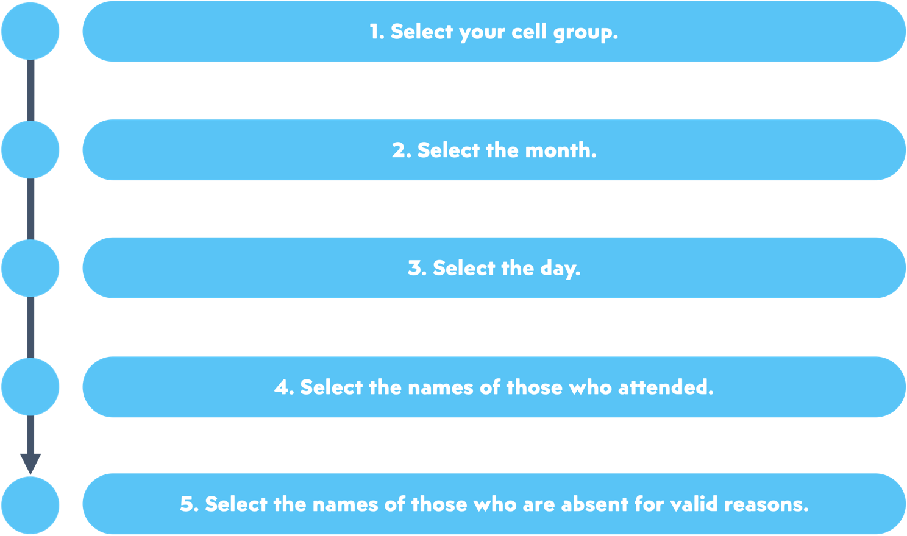

**How do we**

**add new friends?**

**To add new friends, simply spell out their names (preferably first & last names) in step 4’s list of attendees,**

**e.g. Nehemiah Tan.**

🥳

